View4D Manual
Version 2.0

By: Ran Klein, PhD The Ottawa Hospital, Updated: 2017-10-17
rklein@toh.ca Department of Nuclear Medicine

Introduction
View4D is a tool developed by Ran Klein at The Ottawa Hospital to visualize 3D and 4D data sets in Matlab. The tool provides an interactive graphical user interface (GUI) which can be used to visualize the volume images. It is particularly well suited for medical imaging applications (e.g. fused dynamic PET and static CT), but can be used for other applications. While the 4th dimension may be used to represent any dimension, in the context of this manual it will be referred to as time-frames.

View4D is made freely available as open source code, and is intended to be customizable for ad-hoc applications.

Key features include:
- Viewing of 3 orthogonal slices and triangulation using the mouse cursor and scroll wheel, producing time-activity curves of the triangulated pixel
- Selection of time-frame range for visualization
- Scrolling, loop play, and sweep play through time-frame data
- Maximum intensity projection (MIP) display (only in the orthogonal planes)
- Threshold mapping
- Fusion with another modality using two color maps and alpha blending
- Superimposed 3D/4D meshes and plots (e.g. regions of interest display)
- Display customization
- Key press and pixel selection call back functions

This manual consists of two parts:
- User Manual is intended as a draft user manual that can be distributed with applications that use View4D and explains how to use the GUI.
- Programmer manual that explain function call options.

For questions and comments please contact Ran Klein at rklein@toh.ca

User Manual
The View4D GUI is demonstrated in the image below. The main figure consists of three orthogonal slices through the image volume which intersect at the cross marks (dashed white lines) and the time-activity curve of the intersection pixel (thick black line on bottom left graph). A Time Frame panel is used to determine the time-frames for display. The Image Scaling and Color map panels are used to control image rendering.
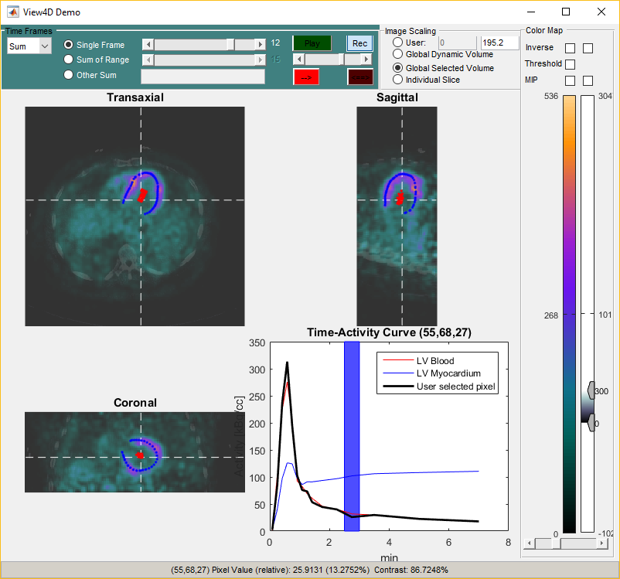

Image Panels
The image panels are the main display. Mouse clicks are used to select the intersection pixel through which all thee image plane cross. In addition, the time-activity curve is updated (only for 4D data sets). The mouse wheel can be used to scroll through the plane that the mouse pointer is hovering over. The pixel coordinates and value are updated on the status bar along with relative intensity and contrast to the maximum intensity pixel.
The intersection point and lines are indicated as cross-hairs which may be toggled off/on using the C key. A right click on the cross-hair brings up a context menu for cross-hair color selection.
The Image panels support fused display in which the primary display supports 3D or 4D data and the optional secondary display is only 3D (i.e. not multiple frame data). (refer to SecondaryVolume property for details on fused display). Viewing of the two volumes is synchronized. The color map behaviors are handled independently and fusion mixing in controlled by the alpha slider in the Color map Panel.
Intersection of additional surfaces and points may be displayed on the image panels if their coordinates are available (refer to the ExtraSurface property).

Time-Activity Curve (TAC)
This chart displays the TAC of the selected pixel (thick black) and additional curves which are available for display (refer to TAC property).
Right click on the TAC brings up a context menu to change the type of data displayed by the TAC line including:
- User selected pixel – TAC of the active intersection pixel
- Max – maximum pixel value at each time-frame
- Mean – mean of all pixels in each time-frame
- Median – median of all pixels in each time-frame
- RMS – root mean square of all pixels in each time-frame
- Standard-deviation – standard-deviation of all pixels in each time-frame
The displayed time frame and range can be set by click and drag of the mouse and the range is indicated by the blue box on the TAC.
Time-frame values and units are set by the Time and TimeUnits properties respectively. Image pixel value units are set by the Units property.

Time Frames Panel
The Frames panel controls the 4th dimension of the data that is displayed and is synchronized with the TAC plot. The 4th dimension may represent time frames, factors, or any other aspect of the data. The frame panel label may be modified using the FramePanelTitle property. The pull down indicates the operation to perform between selected time-frames and includes:
- Sum – sum of pixel values
- Average – mean of pixel values
- Weighted average
- Integral
- Max
The radio buttons are used to select between displaying:
- A single time-frame specified by the top, start-frame slider
- A range of time-frames from start-frame to the end-frame specified by the bottom slider
- A custom range specified by the string in the neighboring text box. Time-frames are listed with comma separations and/or ranges are specified with hyphen separation as detailed in the Filter Strings section. (e.g. “1,2,5-7” includes frames 1, 2, 5, 6 and 7)
The controls on the right half of the panel are used to control video playback through the time-frames. The top button starts/stops the video. The Rec button records the playback to an animated gif file including the entire figure. The scroll bar controls the play speed. The --> button plays a one-way loop and the <--> button plays a back-and-forth sweep.

Image Scaling Panel
This panel controls color scaling of the primary image. Options include:
- User, where the user can select and lower and upper limit by typing them into the neighboring text boxes or using the control sliders on the color bar.
- Global Dynamic Volume – scaled between 0 and the highest value pixel in the entire image volume.
- Global Selected Volume – scaled between 0 and the highest value pixel in the selected time-frame volume.
- Individual Slice – scaled between 0 and the highest value pixel in each displayed slice separately.

Color Map panel
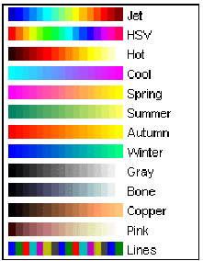
The color map panel enables the user to choose the format in which intensity is translated to color. Changes in this section update both the data display and the color bar, but do not affect the data itself. A selection of preconfigured color maps may be chosen from the context menu (right click on color map). The color maps may also be inverted using the checkbox.
On the secondary volume, color scaling is controlled by dragging the lower and upper limits on the slider. The primary scaling is controlled using the image scaling panel described above. The reason for the differing control methods is to support 4D data on the primary volume, which is not supported in the secondary volume.
The MIP (maximum intensity projection) option changes the image displays to show the highest value pixel in the stacked slices of the corresponding projection. Scrolling through slices is still enabled, but the images will not changes as the MIP is only dependent on the viewing angle which cannot be changed.
Thresholding can be turned on using the corresponding checkboxes, enabling the user to threshold the image space by either image intensities or as a combination of both.

Shortcut Keys
Key | Operation
Left/Right arrow | Scroll start frame
Up/Down arrow | Scroll end frame
C | Toggle cursor on/off
1 | Toggle volume 1 fusion on/off
2 | Toggle volume 2 fusion on/off

Programmer Manual

Demo
View4D is distributed with View4DDemo which demonstrates how to use View4D with various scenarios. The default option includes most of the functionality as is demonstrated in the screenshot in this document.

Input Parameters

View4D(data) - view the data (3D or 4D) matrix.

View4D(data, timeStr) - sets the 4th dimension frames to display at startup. Refer to filterString2Mask function and Filter String section below for more details on the string format.

View4D(data, timeStr, property, value, ...) - Pairs of property and values specific to View4D including:
Property | Description
FigureName | String containing the name of the figure.
FramePanelTitle | String containing frame panel label. If not specified, default is 'Time Frames'.
PixelDimensions | Dimensions of the pixels [dx, dy, dz] to control the image aspect ratio.
Colormap | Color map to be used. Can be either a function name of one of the supported color maps or an array defining the color map. If a string is used, it may be preceded by the letter "i" to indicate inversion of the colormap order.
ScaleLimitsMode | String specifying color limits mode. Options are:  - '[0 max]' - lower limit is fixed to zero.  - '[-max max]' - lower limit is negative -abs(max(data(:)) and upper limit is abs(max(data(:)).
ThresholdScale | Specifies the threshold scale limits in image units [lowerLimit upperLimit]
PointerCallback | Specifies a callback function to execute when user clicks on slices. The function Vie4DCoord can be used in the callback function to determine the coordinates the intersection point of the mouse click and the event object. See DisplayPixelCurve for an example.
Position | The position on the screen for the figure can be specified in two forms:  - [x, y, width, height] - in normalized units [0-1].  - a string in the format supported by the movegui function.
Units | String containing image intensity units name.
Time | The middle frame times (4th dimension) as an array of length dim(data, 4).
TimeUnits | String containing time (4th dimension) units name.
TimeOp | Set the starting operation for the selected time operation:  - ‘Sum' – sum of pixel values  - 'Average' – average of pixel values  - 'Weighted Average' – frame-length weighted average  - 'Integral' – integral of pixel values accounting for frame lengths  - 'Max’ – maximum pixel value
TAC | Additional time activity curves to plot on the time axis as a cell in the format: {intensity1, lineStyle1, nameStr1;  intensity2, linestyle2, nameStr2;…} where  - intensity is an array of curve intensities (same length as number of frames  - lineStyle is plot line style string option  - nameStr is the string label for the curve
ExtraSurface | A surface, whose contours will be superimposed on the slices. Extra surface is a structure or a cell of structures with the following fields:  - X - the x coordinate data  - Y – the y coordinate data  - Z – the z coordinate data (X, Y, and Z must have the same number of elements and be in the form of cells for each time-frame of non-cell if common for all time-frames)  - LineStyle – the line style for plotting the surface contours (e.g. '.r' for red dots)  - Type – the type of information in in the structure  - ‘plot’ or ‘cloud’ – data represents individual points at XYZ.  - ‘mesh’ – data represents a surface. Plot lines of the intersection of the surface with the slices.
SecondVolume | An additional volume image for fused display. It is a structure with following fields:  - vol - the 3D volume image (mandatory).  - pixelDimensions - the pixel size dimensions (optional, assumed image size is same vol unless specified).  - offset - Cartesian coordinate offset between images (x,y,z) in same pixel units as vol (optional, assumed 0,0,0 unless specified)  - alpha - starting alpha mixing between volumes where 0 show only vol and 1 show only secondary volume (default is 0.5).
WaitForClose | Binary option to stops execution of calling function and wait for the user to close the View4D figure before continuing execution. Returns the last time frames used to view in Filter String format.
KeyPressFunc | A callback function to handle additional keys (only those not already in use by View4D).
OtherData | Any other data that should be attached to the figure handle for callback functions.

Output Parameters
frames = View4D(...) – If the 'WaitForClose' option is enabled, returns the frames selected in the GUI as a filter string.

figHandle = View4D(…) – If the ‘WaitForClose’ option is disables the figure handle is returned.

Filter Strings
This string format describes the time frame selection to be summed for display. The format applies to the third input parameter, which initializes the display; and to the second output parameter, which relates to the user selection.
The string includes a set of comma-separated frames, and range of frames following this format:
- N – only time frame N.
- N1-N2 – all frames in the range of N1 and N2 inclusive
Example:
- 1-5,9 - frames 1,2,3,4,5, and 9

- END -

